|  |
| --- |
| **DAYANANDA SAGAR COLLEGE OF ENGINEERING**  (An Autonomous Institute affiliated to VTU, Belagavi, Approved by AICTE & ISO 9001:2008 Certified)  Accredited by National Assessment & Accreditation Council (NAAC) with ‘A’ grade, Shavige Malleshwara Hills, Kumaraswamy Layout, Bengaluru-560078.  **Minor Project Report on**  **“Bot to Analyze the Marks and to Forward Emails and SMS Messages Automatically”**  **Submitted By**  **Prajwal Kumar B R P V Sai Tharunesh Gopa Akash P V Siva Teja**  **1DS18CS092 1DS18CS088 1DS18CS049 1DS18CS089**  **Fifth Semester B.E (CSE)**  **in**  **Emerging Technologies**  **18CS5DMETG**  **Under the guidance of**  **Prof. Poornima K S**  **Assistant Professor**  **Dept. of CSE**  **DSCE, Bangalore**  **Department of Computer Science and Engineering**  **Dayananda Sagar College of Engineering**  **Bangelore-78** |

**ABSTRACT**

**T**his automated bot is created using the resources provided by Automation Anywhere University’s Community Edition. The purpose of this automated bot is to automatically Analyzing the students data by calculating Total Marks, Percentage and Pass or Fail Grade and to Segregate students records into respective sections and return the number of students who have failed and to remind them about the fast-rack or supplementary exam by forwarding a Email and Message to them.

Forwarding Email and Message generically refers to the operation of re-sending an email message delivered to one email address to a possibly different email address(es) or to one phone Number to a possibly different phone Number(s).The project will use IMTP protocol to access the Email of the client.

Instead of the teachers sending all these information to a class rep. and then from the class rep. to the student, this bot will focus on sending the whole and clear information to each and every student who have less grades . This will result in not only reducing the work-loads on teachers and class reps but also it will reduce the time taken to send the mails and messages to the students who need to take fast-rack. This project focuses on the teachers who have to send the mails and messages repeatedly, but it will also help people having a similar kind of situation.

**CONTENTS**

|  |  |
| --- | --- |
| **Heading** | **Page No.** |
| **1.Introduction**  **1.1.Introduction to Automation Anywhere**  **1.1.1. Introduction to Automation Anywhere**  **1.1.2. About RPA and Automation Anywhere Platform.**  **1.2. Objectives**  **1.3. Problem Statement**  **1.4. Scope and importance of the project**  **1.5.System Requirements Specification** | **4-7** |
| **2. Design and Implementation**  **2.1. Flow Diagram**  **2.1.1. Process to be automated**  **2.1.2. Need for automation**  **2.2. Implementation** | **8-9** |
| **3. Testing/Result and Analysis**  **3.1. Bot Execution Procedure**  **3.2. Data set** | **10-12** |
| **4.Conclusions and Future Enhancements**  **4.1. Conclusions**  **4.2. Future Enhancements**  **4.3.References** | **13** |

**CHAPTER 1**

**INTRODUCTION**

* 1. **INTRODUCTION TO RPA**

Robotic Process Automation is the technology that allows anyone today to configure computer software, or a “robot” to emulate and integrate the actions of a human interacting within digital systems to execute a business process. RPA robots utilize the user interface to capture data and manipulate applications just like humans do. They interpret, trigger responses and communicate with other systems in order to perform on a vast variety of repetitive tasks. Only substantially better: an RPA software robot never sleeps and makes zero mistakes.

**1.1.1 Introduction to Automation Anywhere**

Automation Anywhere is one of the popular RPA vendors offering powerful & user-friendly RPA capabilities to automate any complex tasks. It is one of the "Revolutionary Technology" that changes the way the enterprise operates. This tool combines conventional RPA with intellectual elements like natural language understanding and reading any unstructured data.

Automation Anywhere allows organizations to automate the processes which are performed by the humans. It is a Web-Based Management System which uses a Control Room to run the Automated Tasks. Automation Anywhere tool can automate ends to end business operations for companies.

**1.1.2. About RPA on AA platform**

Automation Anywhere Architecture has 3 primary components

1. Control Room : Control room is a web-based platform that controls the Automation Anywhere. In other words, it's the Server that controls automation anywhere bots.
2. Bot Creator : Bot creator Developers use Desktop based applications to create bots. Their development licenses are checked with that configured in the control room.
3. Bot Runner : The Bot Runner is the machine where you run the bot. You could have multiple bots running in parallel. You only need the Run License to run the bots.

## Types of Automation Anywhere Bots

1. Task Bots
2. Meta Bots
3. IQ Bots
   1. **Objective**

To calculate the marks,percentage and grade for the students.

To reduce the workload on people who have to segregate the student records based on sections or percentage.

To reduce the workload on those people who have to forward Email and Messages to those students who have failed to remind them.

To generate the final PDF which will be used for the notice Board and mail that to the respective Instructor.

* 1. **Problem Statement**

Create a bot which will calculate the Marks,percentage and Grade and which will segregate the student records on basis of section and percentage, and sends an Email and a Message as Notice for those Students who have failed in the Exam and calculates the final Notice Board Report.

* 1. **Scope of the work and its Importance**

The bot can be user friendly for the Teachers to calculate the marks which will reduce the work load for the teachers and automatically remind the failed students by sending Mails and Messages without the involvement of actual Teachers which will also reduce the efforts of the teachers and this bot can be used in Colleges, Universities and Schools.

* 1. **System Requirement specification**

Automation Anywhere Software or Community Edition version 11

Machine - can contain any OS

Processor - should be at least Dual Core ,clock speed should be greater than 2.5 GHZ

RAM - Minimum 4 GB required

disk storage - Minimum 250 GB required

Network - should have good network with minimum 250 KBPS.

Bot Agent should be Running as a Service in the Background.

**CHAPTER 2**

**DESIGN/IMPLEMENTATION**

**2.1 Flow Diagram**

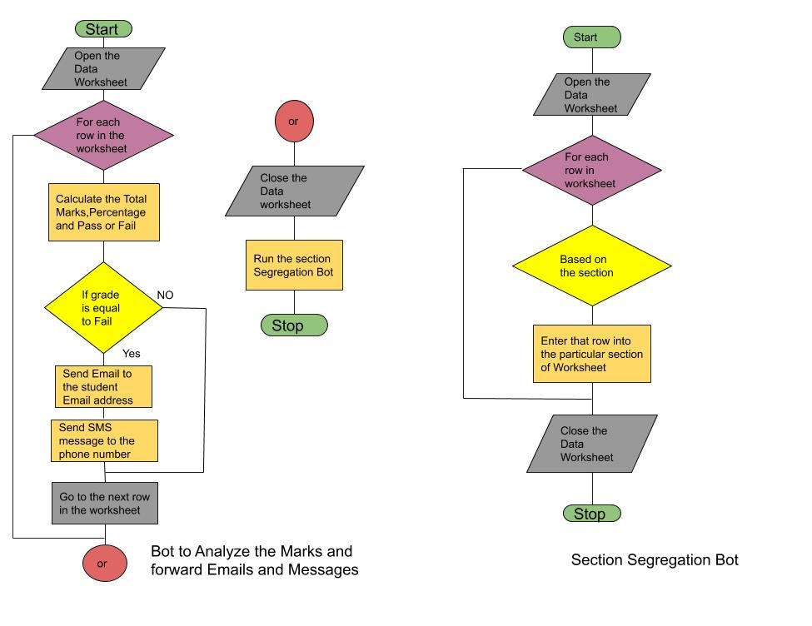



* The Bot opens the Excel Worksheet which contains the Raw Data.
* Loops the each row in the Worksheet and Calculates the Respective Marks, Percentage and Grade for Each Student.
* It examines the Each record and sends the notice reminders through Mails and Messages for the Students who have failed in the Exam.
* The next Segregation Bot will be run as Command by the main Bot.
* Where Segregation Bot segregates the Student Records in the Main Excel Sheet into respective Section Sheets.

**2.1.1. Process to be Automated**

Calculating the Marks,Percentage and Grade can be Automated.

Segregating the students who have failed in the Exam.

Sending the E-mails and Messages as Remainders.

Segregating the Student Records based on Sections into different Spreadsheets.

Sorting the Student Records in Descending Order of Marks and mailing that worksheet as PDF which can be used for Notice Board.

**2.1.2. Why the process should be Automated**

The above process should be automated because it takes lot of time to do manually and many errors can be occurred when it is done manually, whereas if the same thing is done by Bot then it will be Error-free and bots consume very less time compared to the Humans. Bot takes less than few minutes to do a Job where Human takes more than a Day to complete the same Job.Bots are Consistent in nature compare to Humans and the Work can be done at less cost compare to the Humans.

**2.2 IMPLEMENTATION**

* We have a trigger ctrl+s to run the bot.
* Later the bot opens the Raw data excel-sheet, then it loops into each row in excel-sheet to calculate the total marks, Percentage and Grade(Pass/Fail).
* Now the bot compares whether the grade is pass or fail, After the comparison if the grade is fail then the bot sends a Mail and Message to that particular student.
* The Mail or Message is send to particular student to remind them about there Supplementary exam.
* After reminding each student who have failed in exam the next part of the bot starts to execute.
* Here comes the bot to segregate the student records according to their respective section.
* It segregates each student records into 4 sections(i.e A,B,C,D) and then the whole data of the respective student is transferred into his/her perspective section’s excel-sheet.
* Now the bot opens the raw excel-sheet to arrange all the student records in Descending Order according to their total marks, then this data is saved into another excel-sheet.
* The data which is arranged in Descending is transferred and converted into PDF format.
* It only shows the limited data in PDF as it hides the fields like Email, Phone number and Section.
* This PDF is sent as mail, to the instructor as to imply that the job is done by the BOT.

**CHAPTER 3**

**TESTING/RESULT and ANALYSIS**

* 1. **Bot Execution Procedure**

The basic things required for the execution of the bot are.

* G mail or Out look account must be required to send a mail.
* Android message Web Application is required to send the messages to their respective Phone Numbers.
* Worksheet containing a raw data of the students like USN NO,Marks of all the subjects, E mail,Phone numbers and Name
  1. **Screenshot of instructions in control room**

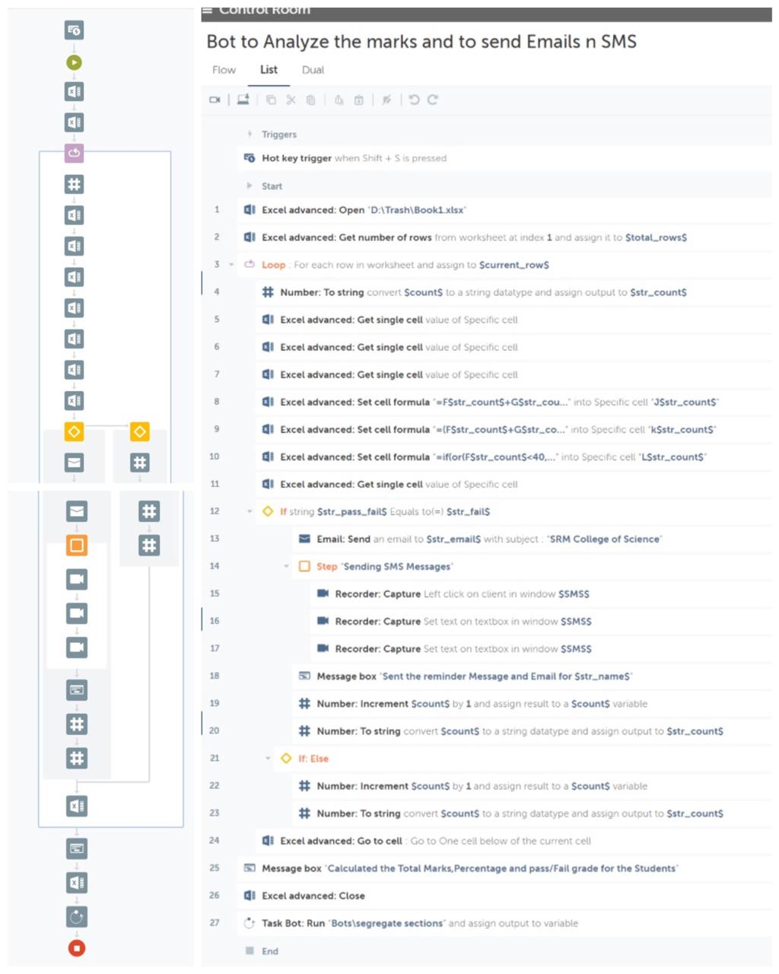

**Fig.1**

The Fig.1 shows the control room of the Bot, Bot to analyze the marks and to send the E-mails and SMS Messages.

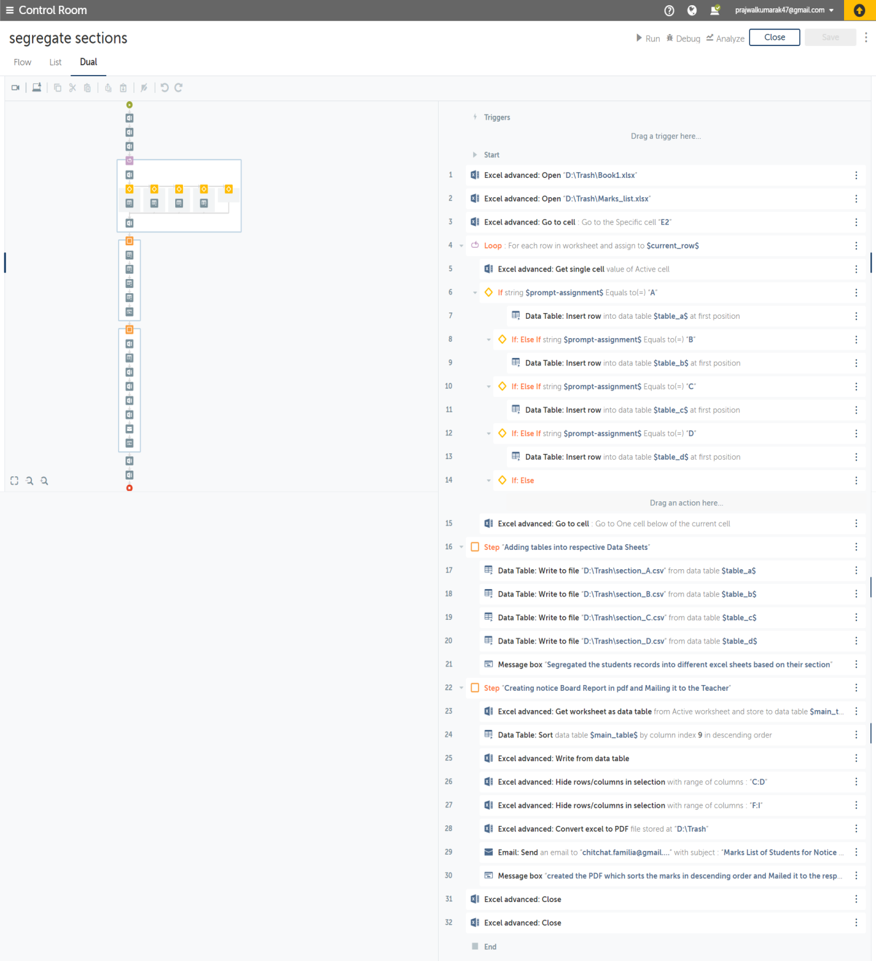

**Fig.2**

The Fig.2 shows the control room of the Bot, Bot to Segregate the Student Records based on the Sections.

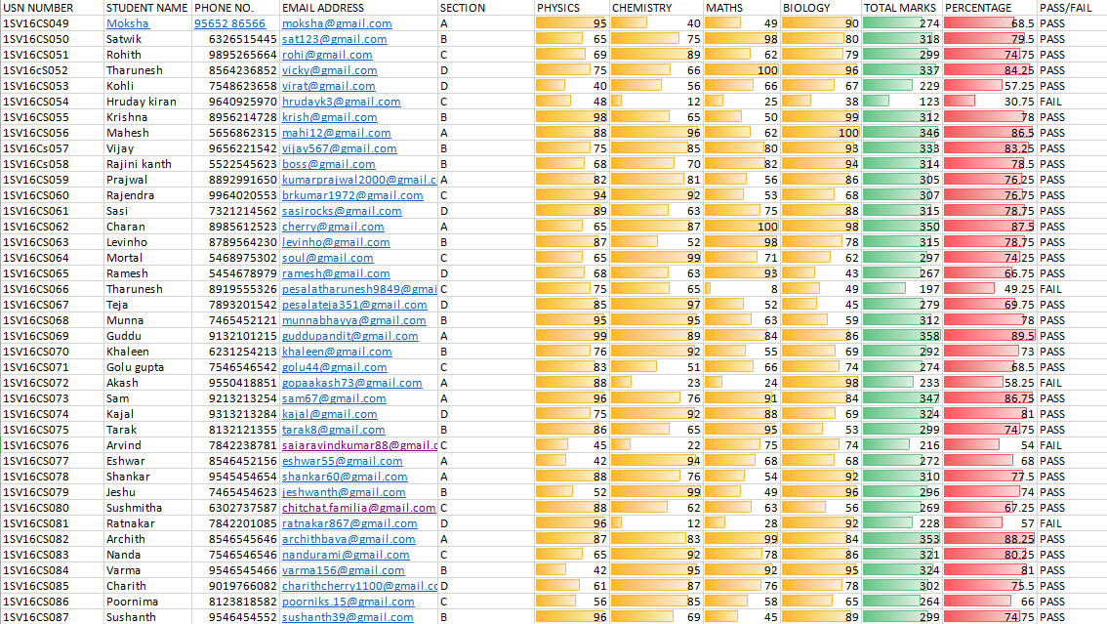

**Fig.3**

In Fig.3, the Bot calculates the Total Marks, Percentage and Grade fields in the above Raw Excel Sheet.

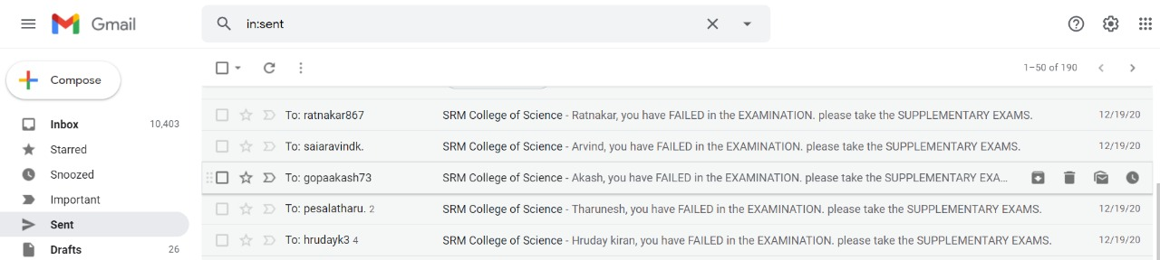

**Fig.4.1**

In the Fig.4.1,we can see that the bot is sending the mails to the students who got “FAIL” grade.

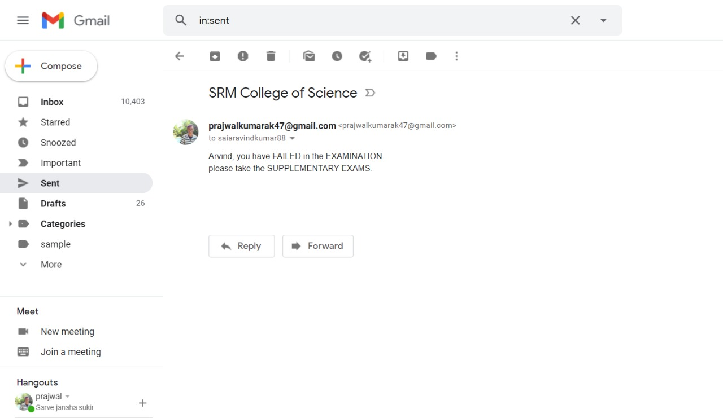

**Fig.4.2**

In Fig.4.2, we can that the bot sends a message to the failed students,informing to take the further exams.

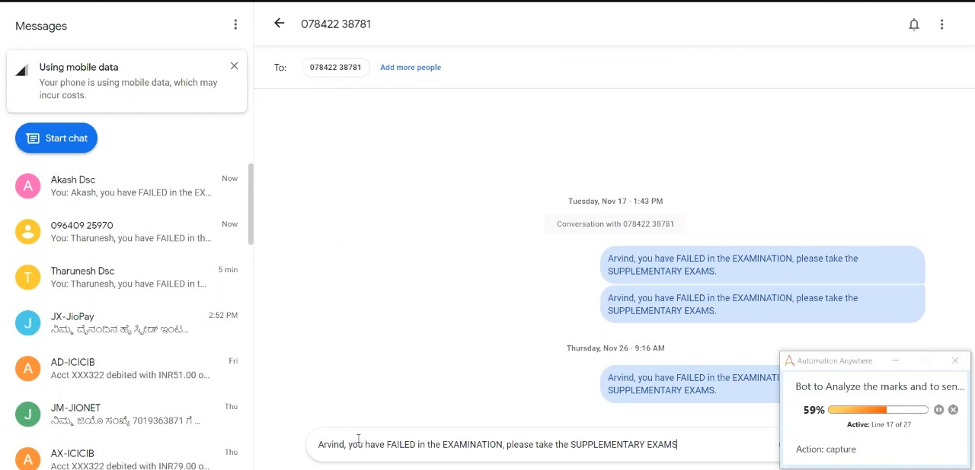

**Fig.5**

In the Fig.5, we can see that the bot automatically sending the messages to the students, who’s grade is fail.

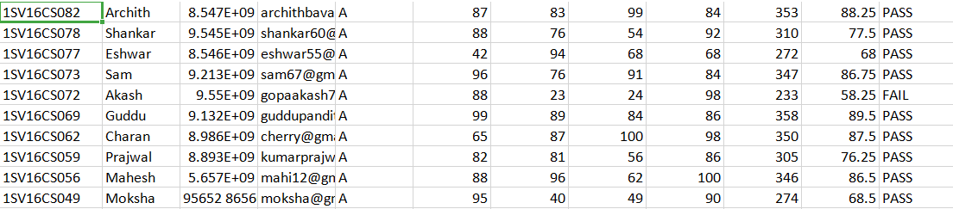

**Fig.6**

In Fig.6, the Student Records are Segregated On Basis of Section,the above picture contains the Student records for the Section A.

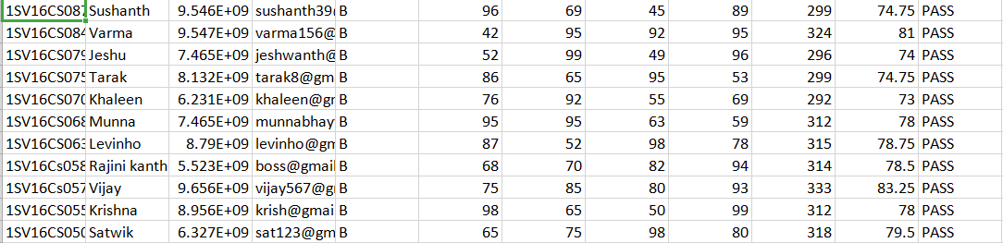

**Fig.7**

In Fig.7, the Student Records are Segregated On Basis of Section,the above picture contains the Student records for the Section B.

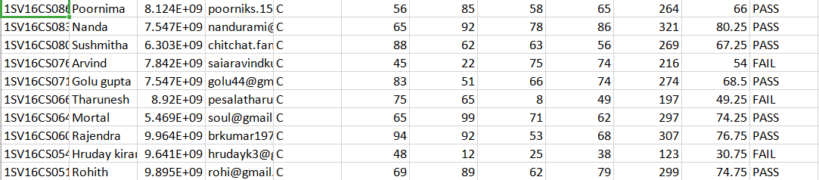

**Fig.8**

In Fig.8, the Student Records are Segregated On Basis of Section,the above picture contains the Student records for the Section C.

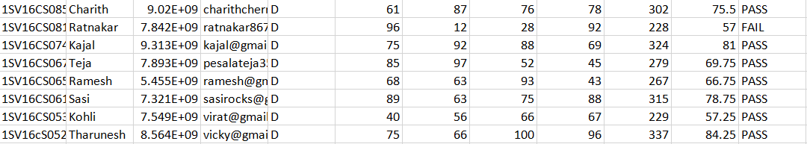

**Fig.9**

In Fig.9, the Student Records are Segregated On Basis of Section,the above picture contains the Student records for the Section D.

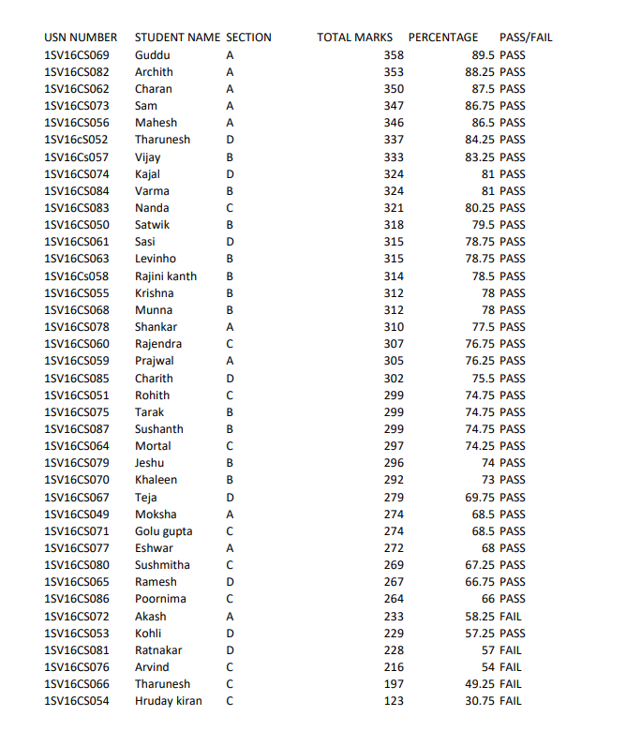

**Fig.10**

In the Fig.10, the records are arranged in Descending Order, By that we can decide the rank of the Students, and we can use that PDF to attach it on the notice Board.

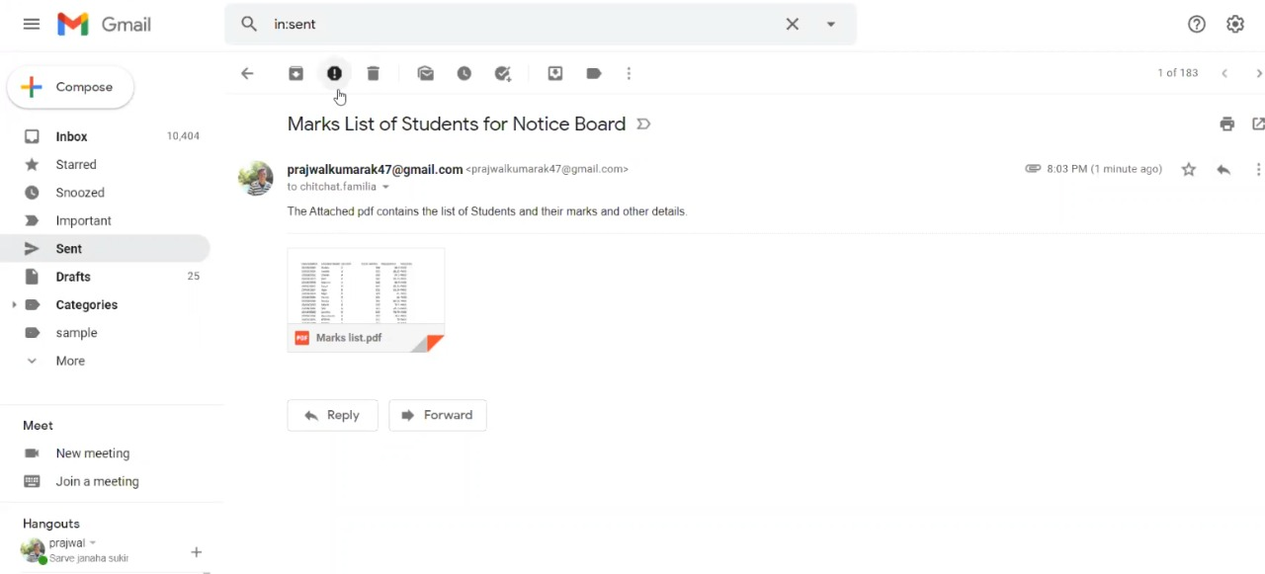

**Fig.11**

In Fig.11, the final PDF is mailed to the respective teacher such that the teacher can rank the students based on the total marks.

**Chapter 4**

**Conclusions and Future enhancements**

**4.1. Benefits of Automating the Tasks**

Lower operating cost,

Bots can perform the work of three to five people, depending on the **task.**

Reduced faculty lead times.

Freeing up staff for higher value tasks.

Faster ROI (Return on Investment )

Reduced output variability.

Reduced paper use/waste.

Ability to be more competitive.

Increase in the output.

Higher Speed and throughput.

Improved Students Experience.

Can able to handle the records Smoothly.

**4.2. Further Enhancements**

Taking the replies from the failed students, whether they are willing to take Re-Exams or ready to apply for Re-Correction.

Allotting the dates for the students who have applied for the Supplementary Exams and mailing them to the Students.

Sending the payment links for those students who are ready for the supplementary exams.

**4.3. References**

<https://www.youtube.com/playlist?list=PLkkGqdBS1r08Fd6meBZ7zHJXA15Q5Up2w>

**PROJECT SYNOPSIS**

|  |  |  |  |  |
| --- | --- | --- | --- | --- |
| DEPARTMENT | Computer Science and Engineering | | | |
| TITLE OF THE PROJECT | Bot to Analyze the Marks and to Forward Emails and SMS Messages Automatically | | | |
|  |  | | | |
| STUDENT NAMES/ USN/ PHONE/ MAIL ID | Prajwal Kumar B R | Sai Tharunesh P V | Siva Teja P V | Gopa Akash |
| kumarprajwal2000@gmail.com | Pesalatharunesh9849@gmail.com | Pesalateja351@gmail.com | Gopaakash73@gmail.com |
| 1DS18CS092 | 1DS18CS088 | 1DS18CS089 | 1DS18CS049 |
| 8892991650 | 8919555326 | 7893201542 | 7989377598 |
| MINI - PROJECT TIMELINE  (Tentative Start date- End Date) | September 2020- December 2020 | | | |
| PROJECT GUIDE DETAILS | Prof. Poornima KS | | | |
|  |  | | | |
| FIELD OF PROJECT | The project is in the field of Robotic Process Automation .Robotic process automation (RPA) is the use of software with artificial intelligence ([AI](https://searchenterpriseai.techtarget.com/definition/AI-Artificial-Intelligence)) and [learning](https://searchenterpriseai.techtarget.com/definition/machine-learning-ML) capabilities to handle high-volume, repeatable tasks that previously required humans to perform.  These tasks can include queries, calculations and maintenance of records and  transactions. | | | |
| BACKGROUND OF PROJECT WITH REGARD TO THE DRAWBACK ASSOCIATED WITH EXISTING PRODUCT/PROJECT | Analyzing the students data by calculating Total Marks, Percentage and Pass or Fail Grade and to Segregate students records into respective sections and return the number of students who have failed and to remind them about the fast-rack or supplementary exam by forwarding Email and Message to them.  Email forwarding generically refers to the operation of re-sending an [email](https://en.wikipedia.org/wiki/E-mail) [message](https://en.wikipedia.org/wiki/E-mail) delivered to one [email address](https://en.wikipedia.org/wiki/Email_address) to a possibly different email address(es).  Message forwarding also refers to the same as Email forwarding but for different numbers.Email forwarding can also redirect mail going to a certain address and send it to one or more other addresses. | | | |
| OBJECTIVE OF THE  PROJECT | The objective of the project is to reduce the workload on people who have to segregate the student records based on sections,percentage and on those people who have to forward Email and Messages to those students who have failed. | | | |
| PROJECT STATEMENT | Create a bot which will segregate the student records on basis of section and percentage, and to send a Email and Message Notice for those failed students. | | | |
| SUMMERY OF THE PROJECT | The project takes the data from main excel sheet, segregate the student records from main excel sheet into respective section excel sheets and also classify the students based on Pass and Fail Marks and forward the Emails and SMS Messages to those student records present in other excel sheet.  The project will use IMAP protocol to access the email of the student. Email is one of the most ubiquitous business communication tools used in recent years.  As every student has phone number, Sending the Notice Message to their phones is also important and efficient. | | | |
| MODE OF CARRYING OUT THE PROJECT  (Give details such as Lab/  /Innovation Lab details.) | The project will be carried out in the Computer Science and Engineering Department of DSCE. | | | |

|  |  |
| --- | --- |
| INTENDED BENEFICIARIES OF THE PROJECT  (industrial/commercial/R& D/social) | It would be most useful for the Teachers who want to analyze the marks of the Students, and for the people  who are responsible for forwarding Emails and Messages, and for the students  who will get the notice at correct time. |
| ABSTRACT | Analyzing the students data by calculating Total Marks, Percentage and Pass or Fail Grade and to Segregate students records into respective sections and return the number of students who have failed and to remind them about the fast-rack or supplementary exam by forwarding a Email and Message to them.  Forwarding Email and Message generically refers to the operation of re-sending an email message delivered to one [email address](https://en.wikipedia.org/wiki/Email_address) to a possibly different email address(es) or to one phone Number to a possibly different phone Number(s).The project will use IMTP protocol to access the Email of the client . |